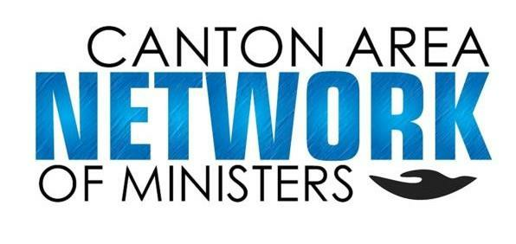

CANM Scholarship 2023
This scholarship was established for students pursuing a career in any field involving
Service and Ministry.
Funding:
Amount: $1,000 ( subject to possible division)
Sponsor: Canton Area Network of Ministers

Scholarship Criteria:
- Must demonstrate qualities of good character and leadership.
- Must demonstrate a strong commitment to improving the quality of life for people in their school, community and/or world at large through their community service.
- Must be entering a college or trade school at the undergraduate level. Pursuant of ministry is preferred but will consider counseling, social work, medical field, or other areas of service.
Applicant Eligibility:
- Must be in the Canton Area or attend a church within the Canton Network of Ministers.
- Must be a graduating senior.
- Must understand the final decision will be determined by the Canton Network of Ministers.

Award restrictions:
- One time gift
- Full time or trade school

Needed Information:
- Student must submit an essay on future academic expectations and goals by March 31st, 2023 to the Guidance Office.
- Student must submit at least one letter of academic recommendation with the above essay at the same time.
- Student must submit a letter of recommendation from their Pastor sharing the gifts and good works of the student and anything else that may be pertinent.
- Student will be interviewed by the Canton Area Network of ministers.

Any questions, please contact member of the Canton Area Network of Ministers: Jennifer Jones at jsjones@susumc.org.

