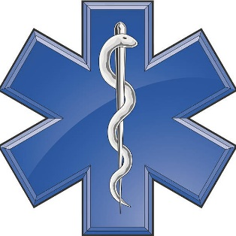
Emergency Medical Technician (EMT)
Class Announcement

Location: Bradford County Department of Public Safety, 29 VanKuren Drive, Towanda, PA 18848

Dates: January 12, 2026 – May 11, 2026

Time: Monday & Thursday Evenings from 1800 – 2200 with two Saturday’s a month from 0800 – 1600

Pre-Requisites: 16 Years of Age or Older with Photo ID for the First Day of Class

Cost: Tuition is free for Bradford County Emergency Responders and is $500 per person for out of County Responders. *Students are responsible for the cost of the textbook and associated materials as well as Cognitive Exam Cost and Background Checks.
This EMT class also includes a refresher option for prior EMT’s to become re-certified as well as an EMR to EMT bridge option for currently certified EMRs.

Course Coordinator: Gregory Jelliff

Registration: Class size is limited to 24 and is on a first-come/first-serve basis. For additional information contact Gregory Jelliff at jelliffg@bradfordcountypa.gov or call 570-265-5022.



