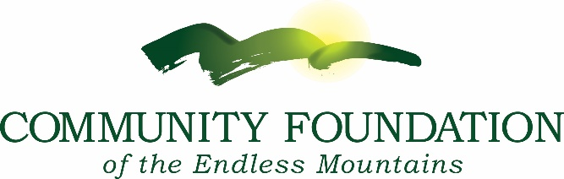
Guidance Office Criteria for Canton High School
Timeline for 2025/2026 School year
November 15th Scholarship applications are available online
March 15th Application deadline
March 22nd Deadline for Guidance contact to supply transcript
March 23rd to April 15th Selection Committees Evaluate Applications
The Community Foundation will notify Guidance of the Award Recipients, provide certificates and instruction letters for award ceremony in mid-May.
All applications are completed online at community-foundation.org/scholarships

Fund Name Criteria
Susquehanna Beekeepers Association College Scholarship: Established by the Susquehanna Beekeepers Association to provide college tuition assistance to students from northeastern Pennsylvania who will major in agriculture or biology and who write a winning essay about their experience as a beekeeper.

