What is USW Local 1000?

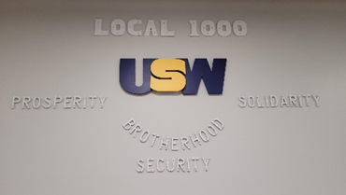
We are a United Steel Workers Local Union located in Corning, NY. Our Local formed in 1945 under the American Flint Glass Workers Union, in 2003 the AFGWU merged with the USW. We are part of District 4 and are active members in the Glass Council of the United Steel Workers. We represent about 1,460 members and almost 2000 retirees. Our employees work in 7 different facilities in what we call the "Valley" which are in Corning, Erwin, Painted Post and Big Flats New York. We have very active Women of Steel and Next Generation Committees, as well as newly established Veteran's and Pride Committees. We are located at 100 Civic Center Plaza in Corning, NY right off from Denison Parkway next to the Radisson and Corning Police Department.


Who are the Women of Steel?

Education. Activism. Service.

Women of Steel is an activist-arm of the USW that evolved from the early women’s caucuses that demanded that women have their rightful place in our union. All female-identifying members of the USW are considered Women of Steel regardless of their union position or the industry or service they work in; some are activists, and some serve on their local’s Women’s Committee.


Who is the Next Generation Committee?

The future of our union depends on our ability to identify the next generation of leaders who will step up when experienced activists are done.

The Next Generation program is a great way to ensure those activists have the knowledge and skills they need to continue the hard work and progress we’ve already made, building a stronger labor movement for generations to come.

Why are we reaching out?

The Women of Steel Local 1000 Committee of Corning, NY has partnered with Next Gen Committee and supported by the Southern Tier Labor Chapter to implement a Scholarship Program for a female recipient of the NY/PA area, who exhibits strong leadership and community activism. The WOS Local 1000 Female Scholarship will be awarded in the amount of $1,000 to one selected recipient who meets and fulfills the requirements. We feel it is very important to invest in our youth including our young women going into the trades field furthering their education.

It is important for females to go into a trade because…
- Current trends in global trade are opening important economic opportunities for women.
- The potential to expand women’s role in the economy, decrease inequality, and expand women’s access to skills and education.
- Creating job opportunities for skilled workers, which increases the incentive to undertake additional training or stay in school.
- Exporters employ more women, and trade creates better jobs for women.
- Giving an equal economic chance to women is not only economically important, but it results in beneficial outcomes for society.

