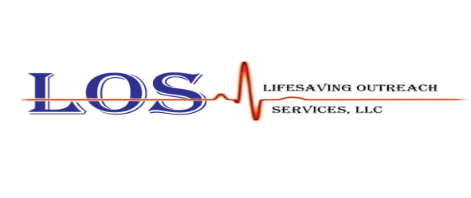
Lifesaving Outreach Services, LLC
presents:
Community Outreach Course
American Safety and Health Institute Babysitting, Childcare, First Aid and CPR Course
February 1, 2026 08:30am-4:30pm
The HSI Child and Babysitting Safety (CABS) program gives teenagers and young adults everything they need to know for safe and successful babysitting. HSI CABS teaches how to start a babysitting business, interact with parents and children, and provides important safety and first aid information using the latest 2020 guidelines. The course is typically meant for students ages 11-16, and lasts about four hours. The afternoon will include First Aid, CPR and AED skills components to enhance the course. The class includes an e-textbook. $100/Student. Pre-registration required and payment accepted day of class. Lunch will not be provided. Students should bring lunch to the class.
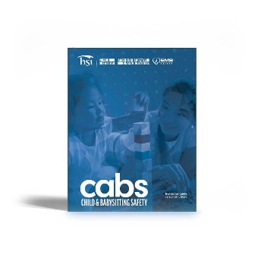
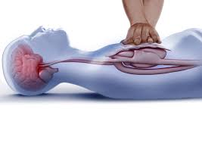
The class will be held at:
Canton VFD Social Hall
51-79 Springbrook Drive
Canton, PA 17724

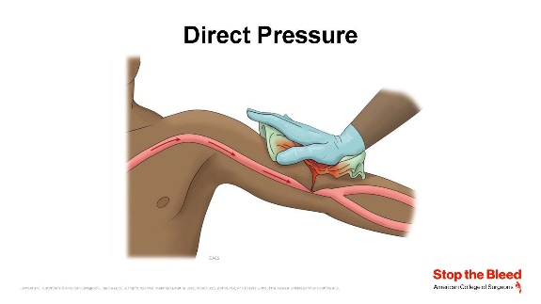
For more information about Lifesaving Outreach Services, LLC visit our website at www.los.llc, email at lifesavingoutreach@gmail.com or call us at 607-731-4217. To register for one or more of the classes, use the QR code or link: https://forms.gle/znRRyFBXwSyk3zRQ9

