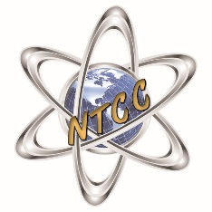
Northern Tier Career Center
120 Career Center Lane
Towanda, PA 18848
(570) 265-8111 Fax: (570) 265-3002 www.ntccschool.org

Collaborative message informing the community of a NTCC staff member testing positive for COVID-19.

Parents/Guardians of Bradford/Sullivan County,

This letter is to inform you that a staff member at the Northern TIer Career Center (NTCC) has tested positive for COVID-19. The staff member is recovering safely at home and following the necessary procedures related to COVID-19. Please understand that the health information, including the names of the positive cases, is confidential to protect their privacy. Administrators at the NTCC are working closely with the Department of Health to identify if there are any students or staff that would be considered a close contact to this staff member. Administrators from both the home district and NTCC will make contact with any individuals who may be deemed a close contact and need to quarantine for a period of 14 days. ALL NTCC students and staff have been notified of the COVID-19 positive case.

Everyday protocols are in place to keep NTCC students and staff as safe as possible. NTCC facilities are cleaned daily, including high touch and traffic areas multiple times a day. We ask that students and staff continue screening daily before coming to the Career Center and please stay home if you have any COVID-related symptoms. ​

Sincerely,

Gary Martell, Director

