CANTON AREA SCHOOL DISTRICT
Health and Safety Plan

Athletics, Extra & Co-Curricular Activities
Board Approved: December 3, 2020

INTRODUCTION

The COVID-19 pandemic has presented athletics across the world with a myriad of challenges. The COVID-19 virus is a highly contagious illness that primarily attacks the upper respiratory system. The virus that causes COVID-19 can infect people of all ages. Research from the Centers for Disease Control, among others, has found that while children do get infected by COVID-19, relatively few children with COVID-19 are hospitalized. However, some severe outcomes have been reported in children, and a child with a mild or even asymptomatic case of COVID-19 can spread the infection to others who may be far more vulnerable. While it is not possible to eliminate all risk of furthering the spread of COVID-19, the current science suggests there are many steps schools can take to reduce the risks to students, coaches, and their families.

The CASD will take the necessary precautions and recommendations from the federal, state, and local governments, CDC, PA DOH, as well as the NFHS and PIAA. The CASD realizes the knowledge regarding COVID-19 is constantly changing as new information and treatments become available. These recommendations will be adjusted as needed as new information becomes available in order to decrease the risk of exposure for our staff, students, and spectators.

PARTICIPANT INVOLVEMENT

- A Student will be defined as any student enrolled in the CASD who participates in school sponsored athletics, and/or extra & co-curricular activity.
- A Coach/Advisor/Staff Person will be defined as any board approved employee providing supervision to students
- A Head (Coach) Staff member will be defined as any board approved supervising staff member (Coach)

CONSIDERATIONS OF RISK
The descriptions below have been developed as guidelines for coaches, students, parents, student advisors and other staff involved to make informed decisions based on the risk presented by participation in the various athletics, extra & co-curricular activities.

- High Risk: Sports that involve close, sustained contact between participants, lack of significant protective barriers, and high probability that respiratory particles will be transmitted between participants. Examples: football, wrestling, cheerleading (stunts), dance
- Moderate Risk: Sports that involve close, sustained contact, but with protective equipment in place that may reduce the likelihood of respiratory particle transmission between participants OR intermittent close contact OR group sports that use equipment that can’t be cleaned between participants. Examples: basketball, volleyball, baseball, softball, soccer, ice hockey, tennis, pole vault, high jump, long jump, 7 on 7 football
- Low Risk: Sports that can be done with social distancing or individually with no sharing of equipment or the ability to clean the equipment between uses by competitors. Examples: running events, cross country, throwing events, swimming, golf, weightlifting, sideline cheer, marching band, color guard

** High/Moderate Risk Sports may move to a Low Risk category with non-contact modifications.

PLAN DESCRIPTION AND DETAILS

GENERAL CONSIDERATIONS (APPLY TO ALL SPORTS):
- Individuals (student-athletes, coaches, officials, and other athletic personnel) will complete a personal health assessment daily.
  - If your temperature is 100.4 or higher, individual is showing symptoms or is sick, stay home.
  - Cover your mouth and nose with a tissue when coughing or sneezing.
  - Adhere to school adopted plans if you begin to show symptoms.
- Promote healthy hygiene practices such as hand washing (20 seconds with warm water and soap) and employees wearing a cloth face covering as feasible. (Face coverings are required (unless an exemption occurs under Section 3 of the Governor’s order to help decrease potential exposure to COVID-19 respiratory droplets by an infected individual. Face Coverings will be used for athletes while practicing or competing.) Hand Sanitizer will be available for team use as resources allow.
- Regularly and thoroughly wash your hands with soap and water for at least 20 seconds or use an alcohol-based hand sanitizer that contains at least 60% alcohol.
- Ensure facilities have been properly sanitized and have hand sanitizer and disposable masks readily available for practices and contests.
- Intensify cleaning, disinfection, and ventilation in all facilities
- Clean and disinfect frequently touched surfaces and equipment including balls.
- Social distancing of at least 6 feet should be maintained at all times, where feasible. No hugging, high fives, shaking hands, or fist bumps for support/encouragement.
- Social distancing should be maintained during the National Anthem and on sidelines.
- Individuals are required to wear face coverings in accordance with the Secretary of Health’s order, unless they meet the exceptions under Section 3 of this order.
  - Everyone must wear a face covering, such as a mask, unless they fall under an exception listed in Section 3 of the Order. Coaches, athletes and spectators (if permitted) must wear face coverings.
  - Athletes are required to wear face coverings while actively engaged in workouts and competition.
  - There are no color restrictions on face coverings; however, face coverings must adhere to the Restriction on Advertisements or Sponsors Names on Uniforms policy, as adopted by the PIAA Board of Directors.
- If a positive COVID-19 case is determined, follow their school safety plans, Department of Health, CDC, and local health guidelines in determining the plan of action.
- Regularly communicate and monitor developments with local authorities, employees, and families regarding cases, exposures, and updates to policies and procedures
- Identify Staff and students who may be at a higher risk of severe illness from COVID-19 due to underlying medical conditions. (See - CDC “People Who are at a Higher Risk for Severe Illness”)

CONSIDERATIONS FOR STUDENT-ATHLETES and COACHES:
- Teams will make each student responsible for their own supplies.
- Students should wear their own appropriate workout clothing and not share clothing. Individual clothing/towels should be washed and cleaned after every workout.
- Hand sanitizer should be plentiful at all contests and practices.
- Athletes should tell coaches immediately when they are not feeling well.
- Student-Athletes should keep their mouth guards in their mouth throughout the competition. If the mouth guard is taken out proper disinfection of the mouth guard should be performed prior to reinsertion. Hands should also be washed or disinfected before doing so.
- Bring and use your own water bottle.
- Student-athletes are encouraged to shower as quickly as possible after practice and games.
  - Locker rooms for both CHS and visiting teams
  - 10-minute continuous maximum in locker room
  - Social distancing of 6 feet required
  - Masks required (unless in shower and 6 feet apart)
  - Separate JV team and Varsity team entry
- Students, Coaches/Advisors, and appropriate Staff will undergo a COVID-19 health screening prior to any practice, event, or team meeting. The type of screening will be dependent upon the available resources. The purpose is to check for signs and symptoms of COVID-19.
- Communicate your guidelines in a clear manner to students and parents.
- Consider conducting workouts in “pods” of same students always training and rotating together in practice to ensure more limited exposure if someone develops an infection.
- Keep accurate records of those athletes and staff who attend each practice in case contact tracing is needed.
- Coaches should limit game day squad sizes for social distancing purposes.
- Students and Coaches/Advisors may communicate via online meetings (zoom, etc.)
- Students may participate in home workouts including strength and conditioning.
- Students and Coaches/Advisors should abide by guidelines set forth by the local and state governments.

CONSIDERATIONS FOR PARENTS/GUARDIANS:
(A family’s role in maintaining safety guidelines for themselves and others):
- Parents/Guardians should monitor their children of any symptoms prior to any sporting activities. Children who are sick or showing symptoms must stay home. (If there is doubt stay home).
- Parents/Guardians and coaches should assess levels of risk based on individual athletes on the team who may be at a higher risk for severe illness.
- Provide personal items for your child and clearly label them.
- Disinfect your student’s personal equipment after each game or practice.
- Be prepared with face coverings for members of your family if permitted to attend events.
- Inform coaches if your student-athlete has been exposed to someone who is known to have COVID- 19.

CONSIDERATIONS WHEN TRAVELING TO A COMPETITION:
- Communication will be made with the host school prior to the competition to discuss plans.
- Follow all policies and guidelines the host school has communicated.
- Make sure your team is bringing its own medical supplies and emergency action plans.
- Have a plan in place if someone begins to show symptoms.
- Every consideration will be taken as to not expose students to unnecessary or potential high risk exposure.
- Reducing the number of students/coaches/advisors/staff on a bus/van
- Using hand sanitizer upon boarding a bus/van
- Social distancing on a bus
- Wearing of face coverings during transportation
- Alternative transportation arrangements may be made and approved by the CASD administration.
- Communicate with opposing team if students with medical exemptions will be unable to wear face coverings.
- Communicate with opposing schools COVID-19 impacts that could directly interfere with hosting the event.

CONSIDERATIONS WHEN HOSTING A COMPETITION:
- An administrative contact will be provided for all events.
- Communicate (by athletic director) ahead of time with the incoming schools and officials about procedures, policies and guidelines.
Examples to be covered include but not limited to, the following:
- Parking in designated spaces communicated by CASD
- Separate entrances to facility for each team
- No use of water fountains; visitors must bring their own form of hydration
- Bench area seating must comply with current DOH social distancing and face covering rules.
- Communicate with opposing team if students with medical exemptions will be unable to wear face coverings.
- Communicate with opposing schools COVID-19 impacts that could directly interfere with hosting the event.
- Locker rooms will be made available
  - Locker rooms for both CHS and visiting teams
  - 10-minute continuous maximum in locker room
  - Social distancing of 6 feet required
  - Masks required (unless in shower and 6 feet apart)
  - Separate JV team and Varsity team entry
- Emergency action plans available upon request
- Electronic exchange of information will be done electronically
- Facilities will be properly sanitized before the visiting team has arrived.
- Frequently touched surfaces and equipment including balls will be cleaned and disinfected frequently
- Refer to Section titled “COVID-19 Signs and Symptoms” for any athlete showing signs or symptoms of COVID-19.

Pre-Activity Screening:
- Each head staff member (Coach/Advisor) will be the primary point of contact for their respective participants for all communication.
- All coaches/Advisors and participating students will sign the participation waiver (see Appendix 1.0)
- All coaches/Advisors and participating students will be screened for signs/symptoms of COVID-19 as they arrive on campus. Screenings will be recorded daily by the coach/advisor. (See Appendix 2.0 for COVID-19 Screening Form)
- The response to screening questions for each person will be recorded and stored so that there is a record of everyone present in case a student develops COVID-19
- The Athletic Director will be responsible for monitoring the screening of the coach/advisors during the season.
- Any person with positive symptoms reported will not be permitted to take part in the activity. Parental/guardian communication or primary care provider or other appropriate health-care professional will occur immediately.
- Individuals with signs or symptoms of COVID-19 are prohibited from returning until they are symptom free without medication for 24 hours
(48 hours for fever of 100.4F or higher).

Limitations on Gatherings:
- Gatherings in indoor or outdoor facilities are limited to the number of spectators that can be socially distanced by 6 or more feet and all spectators who are not actively engaged in the sport/activity are masked when not seated in the stands or standing stationary while present in the facility at all times. The district and administration will establish capacity limits for all public areas that may be utilized for any non-educational gathering. Those capacity limits will be publicly posted on district website and strictly adhered to. The district and administration reserve the exclusive authority to adjust capacity limits at any time necessary due to updated guidance or mandates from the Commonwealth of PA, Pennsylvania Department of Education, or Pennsylvania Department of Health.
- Students should practice within the same group. Changes to groups can be made gradually as needed. Group attendance will be tracked daily by coaches.
(See Appendix 3.0 for Student Group Attendance Record)
- Concession stands will not be used during athletic events.
- Social Distancing should be applied, where practical, during practices and in locker rooms, and gathering areas.
- The limits on all indoor and outdoor gatherings on school property will comply with all orders from the Governor and the gathering limitations will be established by district administration to ensure masking and 6 feet of social distancing.

Facilities Cleaning:
- Adequate cleaning schedules will be created and implemented for appropriate facilities to mitigate any communicable disease
- School facilities should be cleaned prior to arrival and post activity gatherings and high touch areas should be cleaned more often
- Equipment will be wiped down after an individual’s use
- Appropriate clothing/shoes should be worn at all times in the weight room to minimize sweat from transmitting onto equipment surfaces
- CASD will provide the staff with spray bottles, disinfectant, and paper towels to periodically wipe-down shared equipment, balls, etc. during and at the conclusion of activities.

Physical Activity:
- Activities in all areas of risk may resume as per the guidelines set forth by PIAA and state and local agencies
- Activities should remain non-contact and include social distancing where applicable
- Students should refrain from sharing clothing/towels and should be washed after each activity
- Equipment that may be used by multiple individuals (balls, shields, tackling dummies, shotput, discus, pole vault, etc.) should be cleaned intermittently during practice and events as deemed necessary
- Hand washing with soap and water for 20 seconds should occur periodically during events and practices. Hand Sanitizer may be used as resources allow.
- Appropriate clothing/shoes should be worn at all times in the weight room to minimize sweat from transmitting onto equipment surfaces.
- Spotters for maximum weight lifts should be stationed at each end of the bar.

Hydration:
- Students MUST bring their own water bottle. Water bottles must not be shared.
- Hydration stations (water coolers, water fountains, water cows, water troughs, etc.) will not be utilized

CONSIDERATIONS FOR SPECTATORS:
- Spectators are permitted.
- All sports-related gatherings must conform with the amended guidelines on safe gathering limitations released by the Department of Health on October 6, 2020 (effective 10/9/2020).
  - Seating areas, including bleachers, must adhere to the social distancing requirements of at least 6 feet of spacing for anyone not in the same household. To assist the district, we will mark indoor seating with an “X” to meet the social distancing requirement.
  - Everyone age 2 or older must wear face coverings (masks or face shields) at all times, unless they are exempted in Section 3 of the Secretary of Health’s Order on Universal Face Coverings.
  - Caregivers or spectators should not enter the field of play or bench areas.
  - Non-essential visitors, spectators, and volunteers should be limited when possible, including activities with external groups or organizations. Parents should refrain from attending practices, or volunteering to assist with coaching.
  - Caregivers and coaches should assess levels of risk based on individual athletes on the team who may be at a higher risk for severe illness.
  - Caregivers should monitor their children for symptoms prior to any sporting event. Children and athletes who are sick or showing symptoms must stay home.

CONSIDERATIONS FOR MEDIA:
- Media are permitted but are counted toward gathering limitations.
- The media must make contact with the school prior to attending to make appropriate arrangement for attendance.
- Media members should complete a personal health assessment daily.
  - If temperature is 100.4 or higher, individual is showing symptoms or is sick, stay home.
- Media are required to wear face covering in accordance with the Secretary of Health’s most recent order, unless they meet exceptions under Section 3 of that order.
- Media availability may be limited especially if there are limits on capacity.
- Media will be restricted to areas outside of the team areas.
- Interview request may be limited and should be accommodated only if social distancing protocols can be followed.
- Locker room access and access to student-athletes will be monitored or limited on a case by case basis and, if it occurs, media must wear face coverings while in a building and maintain social distancing in all locations.
- Press box availability may be limited.

CONSIDERATIONS FOR GAME DAY WORKERS:
- Individuals are required to wear face coverings in accordance with the Secretary of Health’s most recent order, unless they meet the exceptions under Section 3 of DOH order.

Current PA guidelines for schools, limit event attendance to students, coaches, game officials, referees, and security. Once that restriction is lifted, event attendance will be determined by groups below ensuring limits on maximum occupancy and social distancing can be maintained.

- Group 1– Participating students (athletes), coaches/advisors, officials, event staff, medical staff, security
- Group 2 - Parents and Other Spectators

COVID-19 SIGNS & SYMPTOMS

What are the signs and symptoms of COVID-19?
Symptoms may appear 2-14 days after exposure to the virus. The symptoms may range from mild to severe. (See Appendix for CDC Fact Sheet)

Symptoms may include:
- Fever or chills
- Cough
- Shortness of breath or difficulty breathing
- Fatigue
- Muscle or body aches
- Headache
- New loss of taste or smell
- Sore Throat
- Congestion or runny nose
- Nausea or vomiting
- Diarrhea

What to do if you are sick?
- If you are sick with COVID-19 or think you are infected with the virus, STAY AT HOME. It is essential that you take steps to help prevent the disease from spreading to people in your home or community. If you think you have been exposed to COVID-19 and develop a fever and symptoms, call your healthcare provider for medical advice.
- Notify the school immediately (Principal, Athletic Director, Athletic Trainer, Coach/Advisor)
- It will be determined if others who may have been exposed (students, coaches/advisor, or other staff) need to be notified, isolated, and /or monitored for symptoms
- If a positive case of COVID-19 is Diagnosed Contact Tracing will be implemented by the Health Department with the assistance of local health professionals and the CDC/PA DOH. (See What is Contact Tracing? in Appendix)

What to do if a student or staff become ill with COVID-19 symptoms during practice, event, or during transportation to or from an event?
- Every effort will be made to isolate the ill individual from others, until the student or staff member can leave the school or event
- If student, parent/guardian will be contacted immediately, and arrangements will be made for the student to be picked up
- Ill individual will be asked to contact their physician or appropriate healthcare professional for direction

Return of student or staff to following a COVID-19 diagnosis?
- Student or staff should have medical clearance from their physician or appropriate healthcare professional, determined to be non-contagious, Fever free (without fever-reducing medicine), improvement in respiratory symptoms (cough, shortness of breath), no vomiting or diarrhea.
- All student athletes who attempt to return to play after a positive COVID-19 diagnosis must complete the steps in the “Return to Plan After COVID-19 Infection in Pediatric Patients” flowchart under the guidance of their primary care physician. (See Attachment)

EDUCATION

All participants (Staff, Coaches, Parents and Students) will be educated on the following (through posters, flyers, meetings, emails, phone calls, social media, etc.):
- COVID-19 signs and symptoms
- Proper ways to limit exposure to COVID-19 (hand washing, cough in your elbow, disinfecting touched surfaces, social distancing, avoid touching eyes, nose, face and mouth, no spitting, gum chewing, etc.)
- No Handshakes/Celebrations (high fives, fist/elbow bumps, chest bumps, hugging), etc.
- The content of this Return to Sport Guidelines Document
- Any pertinent COVID-19 information released by state/local governments, NFHS, and PIAA
- Students should come dressed for activity
- Limit indoor activities and the areas used
- Locker room use is not permitted
- Facility showers cannot be used
- Student should remain with their assigned groups during each activity to limit contact

MODIFICATIONS

If necessary to maintain compliance with guidance, orders, or laws from state, local governments, department of health, or to protect the health and safety of students, staff, or the community, the Superintendent in consultation with the district’s Pandemic team, is authorized to amend this plan as necessary.

Any modifications and changes to the plan will be posted to the district website (www.canton.k12.pa.us) and shared with Coaches/Advisors, Students, Families, and the Board of Directors.

Please see the Appendix for sports specific guidance for all CASD winter sports (Wrestling, Basketball, and Competition Cheerleading)

APPENDIX

Appendix 1.0

Canton Area School District
Athletics, Extra & Co-Curricular Activities
Participation Waiver for Communicable Diseases Including COVID-19

The COVID-19 pandemic has presented athletics across the world with a myriad of challenges. The COVID-19 virus is a highly contagious illness that primarily attacks the upper respiratory system. The virus that causes COVID-19 can infect people of all ages. Research from the Centers for Disease Control, among others, has found that while children do get infected by COVID-19, relatively few children with COVID-19 are hospitalized. However, some severe outcomes have been reported in children, and a child with a mild or even asymptomatic case of COVID-19 can spread the infection to others who may be far more vulnerable. While it is not possible to eliminate all risk of furthering the spread of COVID-19, the current science suggests there are many steps schools can take to reduce the risks to students, coaches, and their families.
The CASD will take the necessary precautions and recommendations from the federal, state, and local governments, CDC, PA DOH, as well as the NFHS and PIAA. The CASD realizes the knowledge regarding COVID-19 is constantly changing as new information and treatments become available. These recommendations will be adjusted as needed as new information becomes available in order to decrease the risk of exposure for our staff, students, and spectators.
These Recommendations include but may not be limited to:
- Students, Coaches/Advisors, and appropriate Staff will undergo a COVID-19 health screening prior to any practice, event, or team meeting. The type of screening will be dependent upon the available resources and the Phase level. The purpose is to check for signs and symptoms of COVID-19.
- Promote healthy hygiene practices such as hand washing (20 seconds with warm water and soap) and employees wearing a cloth face covering as feasible. (Face coverings are recommended to help decrease potential exposure to COVID-19 respiratory droplets by an infected individual. Face Coverings will not be used for athletes while practicing or competing.) Hand Sanitizer will be available for team use as resources allow.
- Intensify cleaning, disinfection, and ventilation in all facilities
- Encourage social distancing through increased spacing, small groups, and limited mixing between groups, if feasible
- Educate Students, Coaches/Advisors, and Staff on health and safety protocols
- Anyone who is sick must stay home
- Have a plan in place if a student or employee gets sick
- Regularly communicate and monitor developments with local authorities, employees, and families regarding cases, exposures, and updates to policies and procedures
- Athletes and Coaches MUST provide their own water bottle for hydration. Water bottles must not be shared.
- PPE (gloves, masks, eye protection) will be used as needed and situations warrant, or determined by local/state governments.
- Identify Staff and students who may be at a higher risk of severe illness from COVID-19 due to underlying medical conditions.

I understand that participating in athletic programs, events, and activities may include a possible exposure to a communicable disease including but not limited to MRSA, influenza, and COVID-19. While particular recommendations and personal discipline may reduce the risk, the risk of serious illness and death does exist. I knowingly and freely assume all such risks, both known and unknown, even if arising from the negligence of others, and assume full responsibility for my participation. I willingly agree to comply with the stated recommendations put forth by the CASD to limit the exposure and spread of COVID-19 and other communicable diseases.

Sport/Activity: _____ ____________________________________

Signature of Parent/Guardian:_________________________________________ Date:______________

Signature of Student:________________________________________________ Date:______________
*Parents/Guardians may request a full copy of the CASD detailed plan. Contact Bob Rockwell AD at brockwell@canton.k12.pa.us.

Appendix 2.0
Canton Area School District
Student and Staff COVID-19 Screening Form
for Athletics, Extra and Co-curricular Activities

Name: ________________________________________ Date: ___________
Grade: _________ Activity: _______________________________________
Students/Coaches/Advisors should self-report as deemed necessary prior to each practice/event. Temperature will be taken from a designated individual as needed. The other symptoms should be marked as “N” NO or “Y” Yes answers.
**For the column “Close Contact” the answer should reflect the following question:
Within the past 14 days have you had close contact with someone who is currently sick with suspected or confirmed COVID-19. (Note: Close contact is defined as within 6ft for more than 15 consecutive minutes, with or without PPE equipment.)

***For the column “Travel” the answer should reflect the following question:
- Within the last 14 days, have you traveled to one of the states that has been recommended by the PA Department of Health to self-quarantine? Self-quarantine states are listed at https://www.canton.k12.pa.us/2020-21-re-opening-of-casd). NOTE: Documentation of a negative Covid-19 test result after returning is sufficient to permit participation.
If any responses are “YES”, student will NOT be allowed to practice or compete, and will be asked to leave school grounds. Athletes may return if they are:
- 10 days since symptoms first appeared and
- 24 hours with no fever without the use of fever-reducing medications and
- COVID-19 symptoms have improved (for example, cough, shortness of breath);
OR
- If the athlete has received medical clearance from a physician (doctor’s excuse) to return to the sport;

OR

- A negative COVID-19 test once placed in quarantine.

Parent/Guardian/Athletic Director will be notified if child answers “yes” to any of the questions.

Date | Temp | Fever And /Or Chills | Cough | Sore Throat | Short of Breath | Loss Taste/  Smell | Vomiting  Diarrhea | Close Contact  ** | Travel  ***

Appendix 3.0
Canton Area School District
Student and Staff COVID-19 Attendance Form
for Athletics, Extra and Co-curricular Activities

Name of Group__________________________

Activity Name (Practice, game, fund-raiser, etc.) ____________________________

Name of Person completing form (Coach/Advisor) __________________________

Students should self-report signs/symptoms of COVID-19 as deemed necessary prior to the beginning of each activity. Attendance logs must be maintained daily and accessible upon request for contract tracing.

NAME | DATE | DATE | DATE | DATE | DATE | DATE | DATE | DATE | DATE
1
2
3
4
5
6
7
8
9
10
11
12
13
14
15
16
17
18
19
20

WHAT IS

CONTACT TRACING
?

BACKGROUND
Contact tracing is the process of reaching out to anyone who came into close contact with an individual who is positive for COVID-19. Contact tracing helps monitor close contacts for symptoms and to determine if they need to be tested. Contact tracing is a key strategy for preventing the further spread of infectious diseases such as COVID-19.
WHAT DOES THIS PROCESS LOOK LIKE?
- In contact tracing, public health staff work with a case to help them recall everyone they have had close contact with during the time they were infectious.
- Public health staff then inform individuals who have had close contact (e.g. “close contacts”) that they have potentially been exposed to COVID-19. Close contacts are only told that they may have been exposed to someone who has COVID-19; they are not told who may have exposed them.
- Close contacts are given education, information and support so they understand their risk. They receive information on what they should do to separate themselves from others who have not been exposed, how to monitor themselves for illness, and are made aware that they could possibly spread the infection to others, even if they do not feel sick.
- Close contacts will be asked to quarantine themselves and are encouraged to stay home and maintain social distancing through the end of their infectious period, which is about 14 days, in case they become sick. They should monitor themselves by checking their temperature twice a day and watch for any other symptoms of COVID-19. Public health staff will check in with these contacts to make sure they are self-monitoring and have not developed symptoms.
- If a close contact develops symptoms, they should isolate themselves and let public health staff know. The close contact will be evaluated to see if they need medical care. A test may be necessary unless the individual is already in a household or long-term care facility with a confirmed case, then the close contact would be considered a probable case without a test.
WHAT TERMS SHOULD I KNOW WHEN IT COMES TO CONTACT TRACING?
- A case is a patient who has been diagnosed with COVID-19. A case should isolate themselves, meaning they should stay away from other people who are not sick to avoid spreading the illness.
- A close contact is an individual who had close contact with a case while the case was infectious. A close contact should quarantine themselves, meaning they should stay at home to limit community exposure and self-monitor for symptoms.
- A contact of a close contact is an individual who had or continues to have contact with a close contact. A contact of a close contact should take all regular preventative actions, like washing hands, covering coughs and sneezes, and cleaning surfaces frequently. A contact of a close contact should be alert for symptoms.

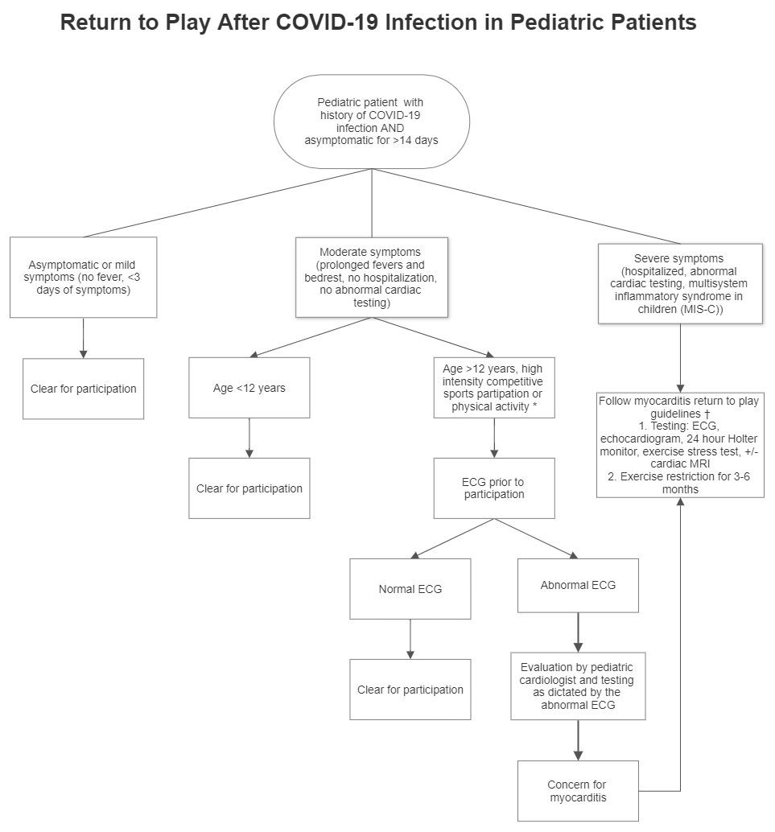

Return to Competition: General Considerations for Wrestling

Pennsylvania Interscholastic Athletic Association (PIAA) National Federation of State High School Associations (NFHS) Sports Medicine Advisory Committee (SMAC)

SPORT: Wrestling STAFF LIAISON: Mark Byers

The NFHS has determined that wrestling is a higher risk sport that involves close, sustained contact between participants, lack of significant protective barriers, and high probability that respiratory particles will be transmitted between participants.

General Considerations:
- Have hand sanitizer and wipes available at the table.
- Wash stations or sanitizer at mat side.
- No one touches the score sheet except the scorer.
- If writing implements are used, they should be sanitized and not shared with anyone.
- Disinfect the mats prior to and following competition.
- Events should be structured to ensure compliance with current indoor occupancy limits and mitigation requirements by the PA Department of Health and Governor’s Office.
- Athletes and Coaches wear masks off the mat.
- Schools should communicate in advance regarding any screening policies and occupancy levels to be expected from the host site.
- Schools may increase the bench area to assist in social distancing.
- For tournament settings, prohibit all wrestlers from warming up simultaneously for competition. Provide for separate warm-up areas off of the competition mats for use and sanitize regularly.
- Provide for separate warm-up mats off of the competition mat for teams involved in dual competition.
- Schools are recommended to only wrestle those schools within their close geographic area.

Considerations for Coaches:
- Wear masks on and off mat.
- Eliminate handshakes with opposing teams post-match.
- Each team should be expected to provide their own leg bands for competition.

Limit the size of their traveling party to include essential personnel, staff, and only those with the ability to wrestle.
- Consider practicing with wrestlers in pods to limit close contacts across the entire team.

Considerations for Wrestlers:
- Daily screening prior to practice and competition should be conducted pursuant to each school’s adopted health and safety plan.
- Shower after each round and put on a fresh uniform, when able and facilities permit.
- Wear masks off the mat when not competing.
- Eliminate handshakes with opposing coaches post-match.
- The use of a fist bump in lieu of a pre and post-match handshake is recommended.

Considerations for Referees:
- Bring personal hand sanitizer. Wash hands frequently
- Don’t share equipment.
- Long-sleeved undershirts are permissible. If worn, they are required to be black in color.
- Change whistle several times during the day.
- Follow social distancing guidelines. Consider six feet minimum distance when talking to others (players, coaches, other officials).
- Consider use of a commercially manufactured whistle cover.
- Do not shake hands and follow pre- and post-game ceremony guidelines established by state associations.
- Officials may recognize the winner of the match by pointing to the wrestler and raising the appropriate color wrist band. Contact with wrestlers is discouraged.
- Officials may wear masks or face shields.
- Mask or face shields are required when not actively officiating the match.
- Officials may wear disposable gloves. If worn, they must change after each match.

Pre-Match Meeting:
- Limit attendees to the referee and one captain from each team.

Considerations for Parents:
(A family’s role in maintaining safety guidelines for themselves and others):
- Make sure your athlete and immediate household members are free from illness before participating in practice and competition (if there is doubt stay home),
- Provide personal items for your child and clearly label them.
- Disinfect your student’s personal equipment after each match or practice which would include wiping down headgear, washing clothing and bags used to transport gear.

Return to Competition: General Considerations for Basketball

Pennsylvania Interscholastic Athletic Association (PIAA) National Federation of State High School Associations (NFHS) Sports Medicine Advisory Committee (SMAC)

SPORT: Basketball STAFF LIAISON: Jen Grassel

The NFHS has determined that basketball is a moderate risk sport (sports that involve close, sustained contact, but with protective equipment in place that may reduce the likelihood of respiratory particle transmission between participants OR intermittent close contact OR group sports OR sports that use equipment that can’t be cleaned between participants).

BASKETBALL RULE CONSIDERATIONS:

Pregame Protocol
  - Limit attendees to the referee, head coach, and one captain from each team with each coach standing on the center circle on each side of the division line.
  - All individuals maintain a social distance of 6 feet or greater at the center circle.
  - Suspend handshakes prior to and following the Pregame Conference.

Team Benches (1-13-1)
  - Social distancing should be practiced when possible.
    - Limit the number of bench personnel to observe social distancing of 6 feet or greater.
    - Place team benches opposite the spectator seating.
    - Additional chairs or rows may be added to allow bench personnel to observe social distancing of 6 feet or greater.
    - Create separation between the team bench and spectator seating behind the bench.
    - Limit contact between players when substituting.
      - Substitutes shall report to the scorer’s table but in the event there is more than one substitution, they may sit at the end of the scores table closest to their bench to maintain social distancing.
    - Coaches and Athletes should adhere to the current Pennsylvania Secretary of the Department of Health Order of July 1, 2020.

Officials Table (2-1-3)
  - The host will sanitize the table before the game and at half time.
  - Place officials table sufficiently away from the sideline to allow for additional space for substitutes.
  - Limit seats at the table to essential personnel which includes home team scorer and timer with a recommend distance of 6 feet or greater between individuals. Other personnel (visiting scorer, statisticians, media, etc.) may not be deemed

essential personnel and consider an alternate location for them.
- Table personnel should adhere to the current Pennsylvania Secretary of the Department of Health Order of July 1, 2020.
- Pre and Post Game Ceremony
  - Suspend the pregame introduction handshakes.
- This includes shaking opposing head coach and officials prior to the game.
  - Suspend post game protocol of shaking hands.

Basketball Rules Interpretations

EQUIPMENT AND ACCESSORIES
- Basketball
  - Ball shall be sanitized as recommended by the ball manufacturer and not used for warm-ups.
  - The host school should ensure that the ball is sanitized during time- outs and between quarters.
- Cloth face coverings are permissible for players.
- Coaching staff and other bench personnel shall follow the current Pennsylvania Secretary of the Department of Health Order of July 1, 2020.

Officials Uniform and Equipment
- Long-sleeved shirts are permissible.
- Electronic whistles are permissible (supplies are limited).
  - Choose a whistle whose tone will carry inside.
- Cloth face coverings are permissible.
- Officials should have face coverings readily available in the event they will be conversing with players/coaches/game personnel within six feet.
- Gloves are permissible.

Other Considerations

Throw-in
- Official may stand 6 feet or greater away from player making the throw-in and bounce the ball to that player on a front court throw-in.

Free Throw Administration
- The lead official shall stand on the end line and bounce the ball to the free thrower.

Jump Ball
- Official can designate another official to toss the ball in the center restraining circle for all jump-ball situations. (Rule 2-5-1)

Scorebook
- Officials do not need to sign the score book but will need to have verbal verification on roster and starter submissions prior to the 10-minute mark.

Return to Competition: General Considerations for Competitive Cheer

Pennsylvania Interscholastic Athletic Association (PIAA) National Federation of State High School Associations (NFHS) Sports Medicine Advisory Committee (SMAC)

SPORT: Competitive Cheer STAFF LIAISON: Melissa Mertz

The NFHS has determined that competitive cheer is a higher risk sport that involves close, sustained contact between participants, lack of significant protective barriers, and high probability that respiratory particles will be transmitted between participants.
**It’s PIAA’s position that Competitive Cheer competition may be considered no more than a moderate risk, with the following considerations: Routines are no more than 2 ½ minutes in length, contact among team members falls below stated CDC guidelines of less than 6 feet for 15 minutes or more and competition does not involve any contact with members of another team/school.

COMPETITIVE CHEER RULES CONSIDERATIONS:
- Cheerleading General Risk Management Sideline and playing surface placement during game.
  - Participants should be appropriately spaced on the court, field or sideline to ensure proper social distancing.
- Cheerleading Apparel / Accessories Jewelry of any kind is prohibited except for the following: A religious medal without a chain is allowed and must be taped and worn under the uniform. A medical-alert medal must be taped and may be visible.
  - Masks may be worn but are not required. No masks may be worn in routines that involve stunting. Any mask worn during a routine that does not involve stunting but involves tumbling must be taped and secure.
- Other Spirit Considerations Cheerleading General Risk Management: Judge placement during adjudicated performance and competition.
  - Judges, officials, adjudicators, etc. should be appropriately spaced to ensure proper social distancing.

PREVENTATIVE ACTIONS:
- The primary consideration is to begin any activity, practice, etc. with a clean space.
- Clean/sanitize surfaces with cleaner/accepted methods listed on the Environmental Protection Agency’s list of disinfectants for use against SARS-CoV-2 as directed by the CDC, or as may be reasonably necessary.
- Mats should be cleaned at least each day of activity or as needed according to current guidelines. If different groups are meeting in the same space at different times, mats should be cleaned between groups.

- Any athlete that feels ill during activity should be isolated and picked up by parents/guardians as soon as possible.
- Provide access to handwashing areas and wash hands during breaks or as reasonably necessary, with particular attention after participating in stunts.
- Athletes, coaches, and support staff who are a member of a high-risk group or live at home with a member of a high-risk group should consider attending training sessions virtually.
- Athletes and parents should be made aware of current best practices for minimizing the spread. Athletes should be sure to wash their hands thoroughly and/or use hand sanitizer before, during, and after practice and should avoid touching their face.
- Athletes should maintain their equipment themselves and there should be no other shared equipment, including, but not limited to the following:
  - Water bottles
  - Poms
  - Megaphones
  - Signs

PHYSICAL DISTANCING:
- Use proper physical distancing to minimize contact.
- Limit contact between groups at exits and entrances by staggering arrival/departure times between cohort groups (individual stunt groups, teams, etc.) and designating separate entrances and exits when possible.
- Avoid congregating before, during, and after practice.
- Contact and physical distancing should follow all local health directives.
- Keep stunt groups together in their cohort. Refrain from mixing and matching bases and tops from different groups.
- Keep stunt groups distanced from other stunt groups when possible (i.e. when not building pyramids), while allowing for all groups to remain on the proper surface for stunting.

The type of contact found in cheer can vary greatly and can be adjusted to meet local distancing guidelines.

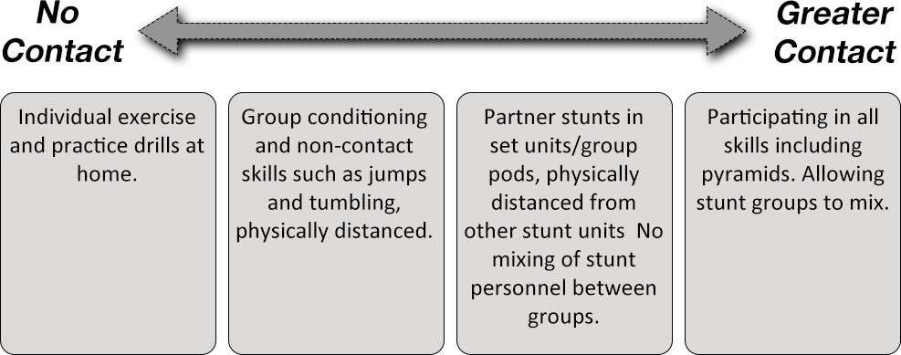

Physical contact with other teams: Participation in cheer and STUNT does not involve physical interaction with other teams. In this regard, contact during games and competition is similar to that found in volleyball or tennis.

FACE COVERINGS:
USA Cheer recommends allowing face coverings with the following guidelines:
- Face coverings should not impede vision or movement.
- Face coverings should be soft and pliable with no exposed metal, and should provide adequate ventilation and protection from the spread of particulate matter.
- Modifications to skills should be considered while wearing face coverings, such as limiting inversions, twisting, and tosses.
- Face coverings should be snug-fitting.

Use these examples when considering face coverings.
- Coverings that are held in place with over-the-head straps using Velcro or other breakaway type connections.
- Full head coverings.
- Coverings that minimize the chance of having fingers caught in them or shifting to impede any visual sight.

PHYSCIAL READINESS:
- Due to shutdowns and general isolation, many athletes have not participated in an activity in several months. Even with individual conditioning and practicing jumps and tumbling, athletes will need a period of acclimatization to prepare for physical activity

