Ridgebury Volunteer Fire Company - Robert Bowman Memorial Scholarship

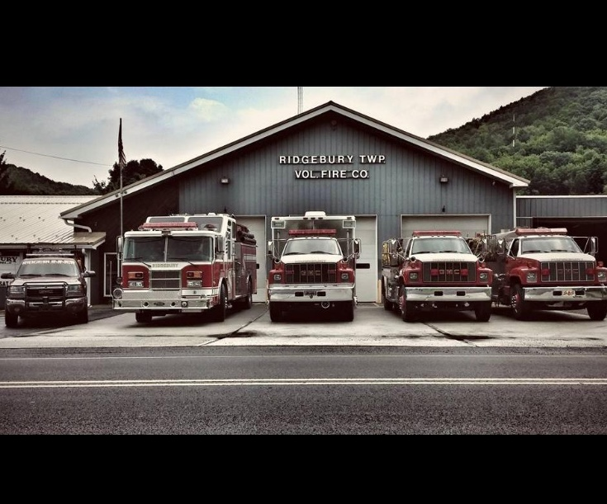

Ridgebury Volunteer Fire Company - Robert Bowman Memorial Scholarship Application
You must submit your materials to the Ridgebury Volunteer Fire Company; by April 1, applications can be handed directly to the RVFC President or mailed to:
Ridgebury Volunteer Fire Company
13248 Berwick Turnpike
Gillett, PA 16925

Personal Information
First Name: ______________________ Last Name: _______________________
Address: ________________________ Home Phone: _______________________
________________________
E-Mail: ________________________
City: ________________________
State: _______ Zip: ________

Educational Information
High School: __________________ SAT Math: _______________________
GPA: __________________ SAT Verbal: ______________________
Graduated in: __________________ SAT Total: _______________________

Extracurricular Activities
Activity Roles and Responsibilities
1. ____________________ ________________________________________________
________________________________________________
2. ____________________ ________________________________________________
________________________________________________
3. ____________________ ________________________________________________
________________________________________________
4. ____________________ ________________________________________________
________________________________________________
5. ____________________ ________________________________________________

Higher Educational Information (Proof of acceptance required)
College Planning to attend: _______________________
Planned Major: _______________________
Planned Graduation date: _______________________

Eligibility Requirements and Conditions

1. Bradford County Pa. Resident
2. Be a graduating high school student or Current college or technical/trade school students are also eligible.
3. Must already be enrolled in a 4-year undergraduate program or be enrolling for the upcoming fall semester.
4. Must be a member in “Good Standing” of a volunteer fire company or ambulance organization in Bradford County Pennsylvania. (see document RBRVFC)
5. Participation in the program requires a commitment of 72 community service hours (annually) with a volunteer fire department, which can be served before or during the time scholarships are received. This may include but is not limited to: attending meetings, training, fundraisers, cleaning of equipment or fire hall, etc. (Applicant is responsible for tracking hours) (see document RBRVFC)
6. Preference is given to students who are enrolling in degree programs related to fire science, criminal justice programs, or EMT programs.
7. A copy of the participant’s transcript or any form of attendance verification at an accredited technical school, college, or university.

I, _________________________________ have read and understand the eligibility requirements and conditions of the Ridgebury Volunteer Fire Company - Robert Bowman Memorial Scholarship. I give permission to officials of my institution to release transcripts of my academic record and other information requested for considerations. I understand that this application will be available only to qualified people who need to see it in the course of their duties. I waive the right to access the letters of recommendation written on my behalf. I affirm the information contained herein is true and accurate to the best of my knowledge and belief.
Signature: ____________________________________ Date:________________

Letter of Membership Validation/Eligibility
Name of Nominee: ______________________________________
Ridgebury Volunteer Fire Company-Robert Bowman Scholarship is selected primarily on the basis of leadership potential, commitment to a career in public service, high academic achievement, and prospects for continuing success.

Your Name: ________________________________ Phone: _____________________________
Title: _____________________________________
Address: ____________________________________________________________________________
____________________________________________________________________________________
How long have you known the nominee? ___________________________________________________
In what capacity? ______________________________________________________________________
Character Traits: (Please check all applicable)
☐ Honest ☐ Compassionate ☐ Respects Authority
☐ Reliable ☐ Trustworthy ☐ Eager to Learn
☐ Dependable ☐ Teachable ☐ Leadership Qualities

Please confirm applicant has completed the required 72 hours of service as required.

Signature: _____________________________________ Date: ______________________________

Please sign and return the completed form to the address noted below. Your evaluation will become part of the nominee’s confidential file, for use only by the Robert Bowman Memorial – Ridgebury Volunteer Fire Company Scholarship Selection Committee.
You must submit your materials to the Ridgebury Volunteer Fire Company; by April 1, recommendation letters can be handed directly to the RVFC President or mailed to:

Ridgebury Volunteer Fire Company
13248 Berwick Turnpike
Gillett, PA 16925

