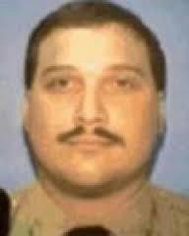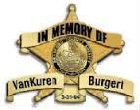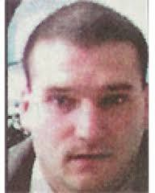

Deputy Sheriff Tragically Killed in the Line of Duty on 3/31/04 Deputy Sheriff Michael VanKuren Christopher Burgert

2022 Bradford County Deputy Sheriff's Memorial Scholarship
Sponsored by the Bradford County Deputy Sheriff Benevolent Association

Two $500.00 scholarships will be awarded to high school seniors pursuing a career in Law Enforcement

Applications may be obtained at your school's Guidance Counselor's Office. Applications must include a typed essay (300 words or more) of why you are choosing Law Enforcement as a career. Winners will be chosen on the content of the essays. Applicants must be of good moral character.

Applications with typed essays must be submitted to your Guidance Counselors Office by May 1, 2022
APPLICANT INFORMATION
NAME: PHONE #: ADDRESS: HIGH SCHOOL: INSTITUTION OF FURTHER EDUCATION: ADMISSIONS OFFICE ADDRESS: ADMISSIONS OFFICE PHONE #:
Include your typed essay with application

