CANTON AREA SCHOOL DISTRICT
“WARRIOR PRIDE”
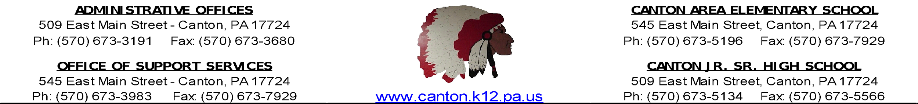

CHS Early Dismissal Form

Dear Senior Parent/Guardian and/or NHS Parent/Guardian,

Since your student has reached their senior year, is in satisfactory academic standing and/or has been accepted into the CHS National Honor Society, he/she will be eligible for an early release from school each day beginning at 2:26pm. This early dismissal is a privilege and may be revoked based on the student’s academic and behavioral performance. Below are the guidelines for early dismissal.
- Maintain appropriate academic standing as determined by the administration
- Maintain appropriate attendance as determined by the administration
- Maintain appropriate discipline record as determined by the administration
- Submit the official, signed parent/guardian permission form (below)
- Early dismissal privileges will not be permitted when late start/early dismissal schedules are utilized

Once we have received the completed permission slip below granting permission by the parent/guardian, your student may begin to leave school at 2:26pm. Please return the completed permission slip to the CHS main office.

Please feel free to contact us with any questions.

Sincerely,
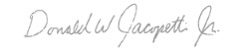
Donald Jacopetti
Principal, Canton High School
-------------------------------------------------------------------------------------------------------------------------------
Please complete the information below and return to the CHS main office.

_______________ I, _________________________ give________________________
DATE PARENT/GUARDIAN NAME STUDENT NAME

Permission to leave school property at 2:26pm for the remainder of the 2022-2023 school year.

Parent/Guardian Signature___________________________

